Arduino Lesson 16
LED 4 Digit. 7-Segment Display
- Intro
This experiments we use the arduino to drive a four digital common anode display. Current limit resistor is a must have, there are two types of current limiting resistor connection, one is in d1 - d4 anode, a total of four. This type requires less resistors, but will show different brightness numbers on each position. #1 is brightest, #8 is the most dark. The other type is connecting with the other 8 pins. This type gives average brightness, but need more resistors. Here we use 8pcs 220Ω resistors. 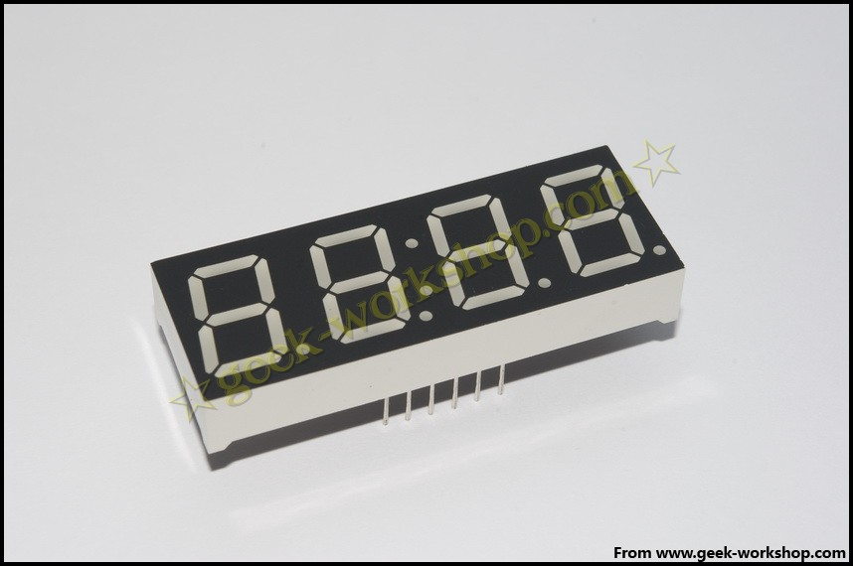
4-digit display has 12 pins. When the dot down and stay put, left bottom one is #1, the others are in counterclockwise order,top left corner one is #12. 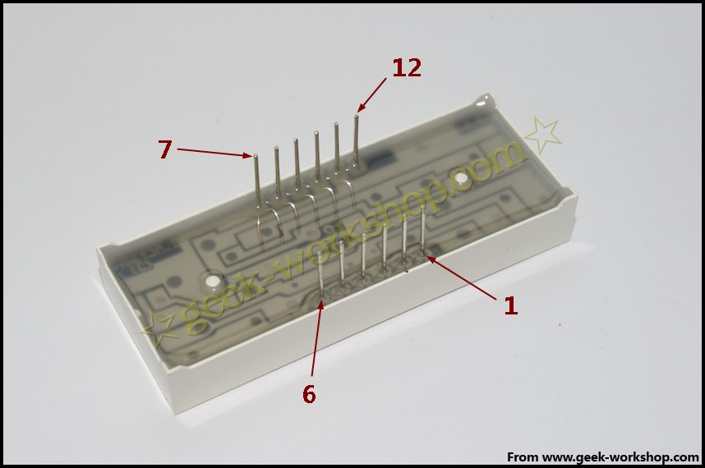
Below picture is the instruction.
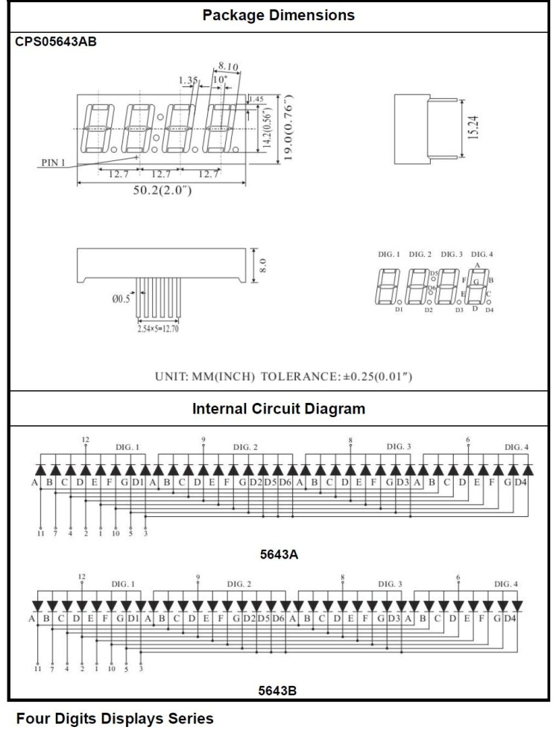

- Connect-it-up

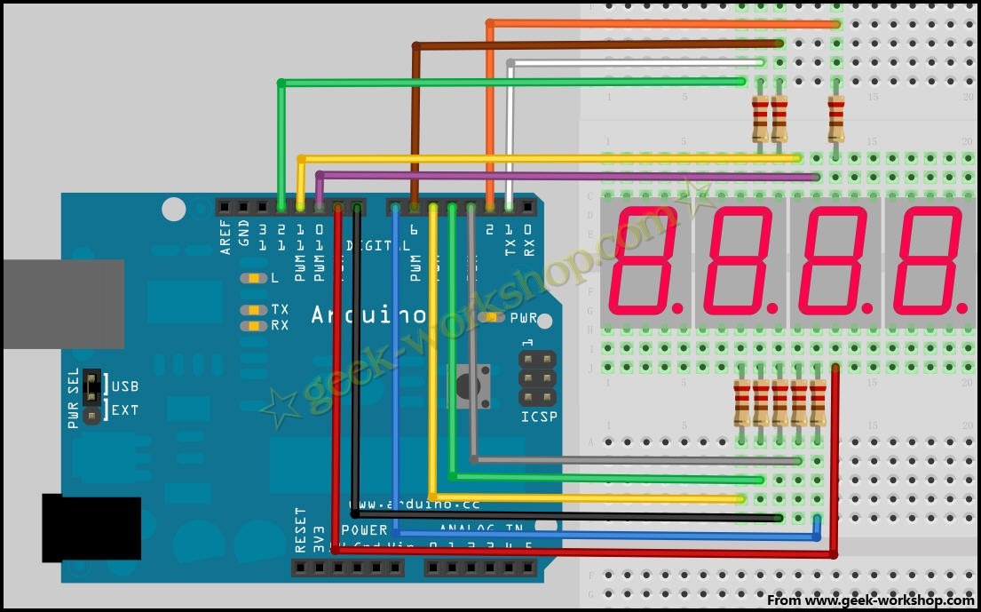
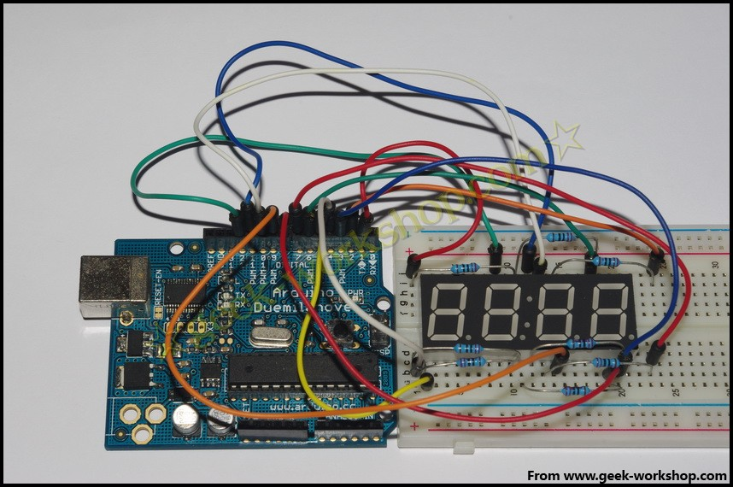

- ARDUINO CODE
- //set the cathode interface
- int a = 1;
- int b = 2;
- int c = 3;
- int d = 4;
- int e = 5;
- int f = 6;
- int g = 7;
- int p = 8;
- // set the anode interface
- int d4 = 9;
- int d3 = 10;
- int d2 = 11;
- int d1 = 12;
- //set variable
- long n = 0;
- int x = 100;
- int del = 55; //fine-tuning value for clock
- void setup()
- {
- pinMode(d1, OUTPUT);
- pinMode(d2, OUTPUT);
- pinMode(d3, OUTPUT);
- pinMode(d4, OUTPUT);
- pinMode(a, OUTPUT);
- pinMode(b, OUTPUT);
- pinMode(c, OUTPUT);
- pinMode(d, OUTPUT);
- pinMode(e, OUTPUT);
- pinMode(f, OUTPUT);
- pinMode(g, OUTPUT);
- pinMode(p, OUTPUT);
- }

- void loop()
- {
- clearLEDs();
- pickDigit(1);
- pickNumber((n/x/1000)%10);
- delayMicroseconds(del);

- clearLEDs();
- pickDigit(2);
- pickNumber((n/x/100)%10);
- delayMicroseconds(del);

- clearLEDs();
- pickDigit(3);
- dispDec(3);
- pickNumber((n/x/10)%10);
- delayMicroseconds(del);

- clearLEDs();
- pickDigit(4);
- pickNumber(n/x%10);
- delayMicroseconds(del);

- n++;

- if (digitalRead(13) == HIGH)
- {
- n = 0;
- }
- }

- void pickDigit(int x) //define pickDigit(x),to open dx port
- {
- digitalWrite(d1, LOW);
- digitalWrite(d2, LOW);
- digitalWrite(d3, LOW);
- digitalWrite(d4, LOW);

- switch(x)
- {
- case 1:
- digitalWrite(d1, HIGH);
- break;
- case 2:
- digitalWrite(d2, HIGH);
- break;
- case 3:
- digitalWrite(d3, HIGH);
- break;
- default:
- digitalWrite(d4, HIGH);
- break;
- }
- }

- void pickNumber(int x) //define pickNumber(x)to display number x
- {
- switch(x)
- {
- default:
- zero();
- break;
- case 1:
- one();
- break;
- case 2:
- two();
- break;
- case 3:
- three();
- break;
- case 4:
- four();
- break;
- case 5:
- five();
- break;
- case 6:
- six();
- break;
- case 7:
- seven();
- break;
- case 8:
- eight();
- break;
- case 9:
- nine();
- break;
- }
- }

- void dispDec(int x) //set to start the decimal point
- {
- digitalWrite(p, LOW);
- }

- void clearLEDs() //clear contents
- {
- digitalWrite(a, HIGH);
- digitalWrite(b, HIGH);
- digitalWrite(c, HIGH);
- digitalWrite(d, HIGH);
- digitalWrite(e, HIGH);
- digitalWrite(f, HIGH);
- digitalWrite(g, HIGH);
- digitalWrite(p, HIGH);
- }

- void zero() //define 0 as cathode pin switch
- {
- digitalWrite(a, LOW);
- digitalWrite(b, LOW);
- digitalWrite(c, LOW);
- digitalWrite(d, LOW);
- digitalWrite(e, LOW);
- digitalWrite(f, LOW);
- digitalWrite(g, HIGH);
- }

- void one() // define 1 as cathode pin switch
- {
- digitalWrite(a, HIGH);
- digitalWrite(b, LOW);
- digitalWrite(c, LOW);
- digitalWrite(d, HIGH);
- digitalWrite(e, HIGH);
- digitalWrite(f, HIGH);
- digitalWrite(g, HIGH);
- }

- void two() // define 2 as cathode pin switch
- {
- digitalWrite(a, LOW);
- digitalWrite(b, LOW);
- digitalWrite(c, HIGH);
- digitalWrite(d, LOW);
- digitalWrite(e, LOW);
- digitalWrite(f, HIGH);
- digitalWrite(g, LOW);
- }

- void three() // define 3 as cathode pin switch
- {
- digitalWrite(a, LOW);
- digitalWrite(b, LOW);
- digitalWrite(c, LOW);
- digitalWrite(d, LOW);
- digitalWrite(e, HIGH);
- digitalWrite(f, HIGH);
- digitalWrite(g, LOW);
- }

- void four() // define 4 as cathode pin switch
- {
- digitalWrite(a, HIGH);
- digitalWrite(b, LOW);
- digitalWrite(c, LOW);
- digitalWrite(d, HIGH);
- digitalWrite(e, HIGH);
- digitalWrite(f, LOW);
- digitalWrite(g, LOW);
- }

- void five() // define 5 as cathode pin switch
- {
- digitalWrite(a, LOW);
- digitalWrite(b, HIGH);
- digitalWrite(c, LOW);
- digitalWrite(d, LOW);
- digitalWrite(e, HIGH);
- digitalWrite(f, LOW);
- digitalWrite(g, LOW);
- }

- void six() // define 6 as cathode pin switch
- {
- digitalWrite(a, LOW);
- digitalWrite(b, HIGH);
- digitalWrite(c, LOW);
- digitalWrite(d, LOW);
- digitalWrite(e, LOW);
- digitalWrite(f, LOW);
- digitalWrite(g, LOW);
- }

- void seven() // define 7 as cathode pin switch
- {
- digitalWrite(a, LOW);
- digitalWrite(b, LOW);
- digitalWrite(c, LOW);
- digitalWrite(d, HIGH);
- digitalWrite(e, HIGH);
- digitalWrite(f, HIGH);
- digitalWrite(g, HIGH);
- }

- void eight() // define 8 as cathode pin switch
- {
- digitalWrite(a, LOW);
- digitalWrite(b, LOW);
- digitalWrite(c, LOW);
- digitalWrite(d, LOW);
- digitalWrite(e, LOW);
- digitalWrite(f, LOW);
- digitalWrite(g, LOW);
- }

- void nine() // define 9 as cathode pin switch
- {
- digitalWrite(a, LOW);
- digitalWrite(b, LOW);
- digitalWrite(c, LOW);
- digitalWrite(d, LOW);
- digitalWrite(e, HIGH);
- digitalWrite(f, LOW);
- digitalWrite(g, LOW);
- }
Copy the code and download to Arduino and see the effects.

